Using Linear Regression to Evaluate Team Performance

Michael Hockey

Abstract
This paper attempts to use linear regression to come up with a statistic that can be used to evaluate the teams performance throughout the season. In hockey wins, loses/overtime loses, and points are used to evaluate a teams performance throughout a season, but due to hockey’s design there is some randomness that goes into the result of a game, making it hard to distinguish between skill and luck. Using regression analysis we can develop a statistic that will give us a good measure on a team’s performance throughout the regular season.

Keywords: big data, regression analysis, advanced statistics, prediction.

1. BUILDING THE MODEL
1.1 DATA
The data in this paper consists of all NHL teams regular season statistics from the 2020-21 season to the 2023-24 season. In the 2020-21 season the Seattle Kraken had not been established yet, so, for the first year we only have 31 teams, but after that there are 32 teams in the league. This will give us a total of 127 season statistics to work with.
The data was collected from hockey-reference.com, and consists of AvAge, Gp, W, L, OTL, PTS, PTS%, GF, GA, SRS (Simple Rating System), SOS (Strength of Schedule), GF/G, GA/G, PP, PPO, PP%, PPA, PPOA, PK%, SH (Short-Handed Goals), SHA (Short- Handed Goals Against), S, S%, SA, SV%, PDO (Shoot % + Save %), and SO. With the gathered data model selection can begin.

1.2 MODEL SELECTION
Using all possible subsets regression with a full set of K potential predictors, we can fit possible candidate models and choose the best based on some selection criterion. In our case we will be using Adjusted this is because we are using a multiple linear regression and models with a larger number of predictors tend to have a smaller Sum of Squared Residuals: , so we adjust SSR by the number of predictors giving us,

Where n is the population size, and p is the number of predictors. We prefer models with a large .
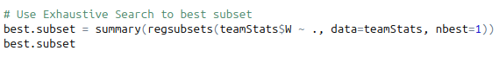
Using R and the regsubsets() function we can find all possible subset regression as,

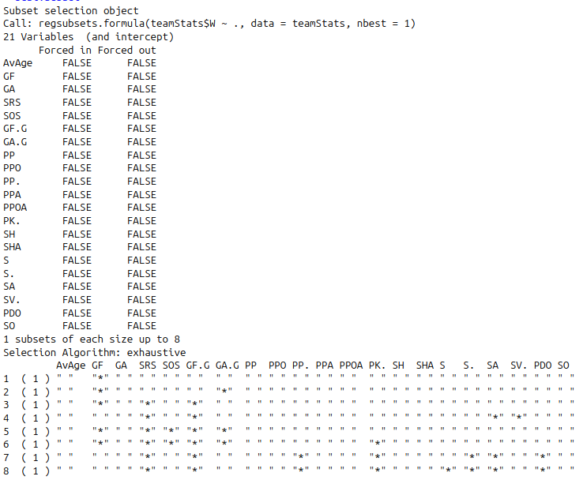

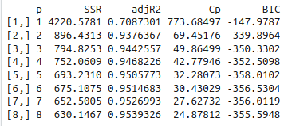
Figure 1 (R output data of all possible subset regression)

From Figure 1 we can see the model with the highest is subset 8, so that will be our “optimal” model going forward.

Where , with .

1.3 MODEL DIAGNOSTICS
1.3.1 LINEAR OBSERVATION
Looking at Figure 2 we can see that the values follow a linear trend, enforcing my idea to create a linear model. Note that the strange jumps in clusters come from the shortened 2020- 21 season.

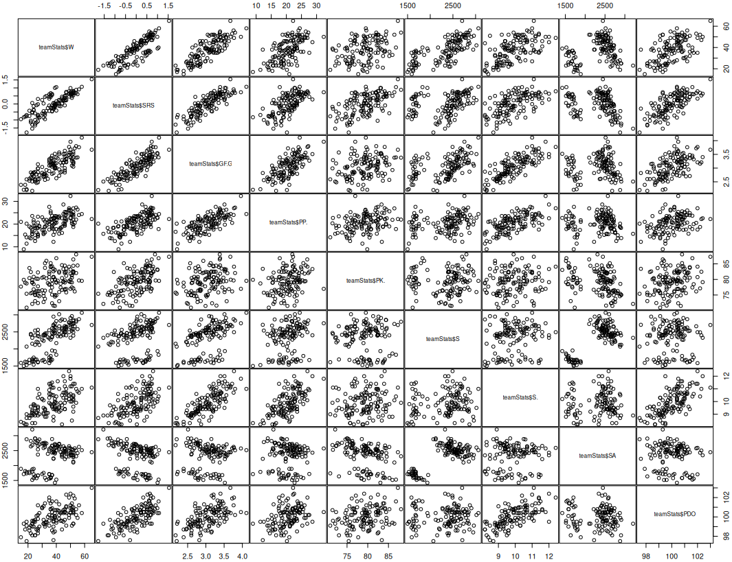

Figure 2 (Plotting explanatory variables against response)
1.3.2 LOOKING FOR OUTLIERS
To conduct residual analysis we need to find the residual vector , standardized residual vector , leverage , and Cook’s distance . After using R to find these values, we can then create our residual plots.

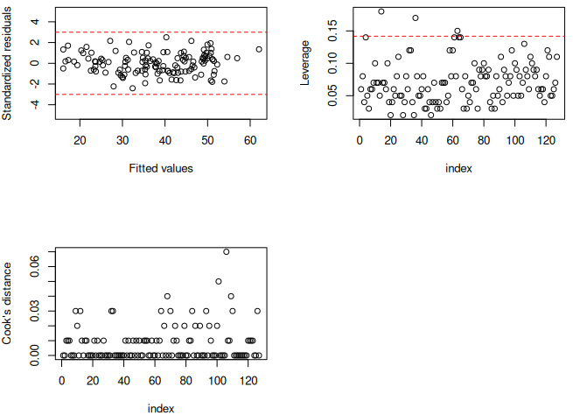

Figure 3 (residual plots [ vs , leverage, Cook’s Distance])
Our Cook’s Distance and vs plots show no outliers, but in our leverage plot we have three values (row 14, 36, and 63) above . This means we have three outliers in the x, they follow the general trend of the model, but far away from the rest of the terms.
Knowing about these three outliers I created three new linear models, each one corresponding to a removed outlier. The of the three models are as follows: 0.954 (removal of 14), 0.9539 (removal of 36), and 0.9532 (removal of 63). Note that the removal of the 14th observation results in a better model by the metric. This will be our model going forward.

Where .
1.3.3 TESTING ASSUMPTIONS OF LINEAR REGRESSION
In Figure 4 we can see most the points lie on the line, meaning the assumption of normality has not been violated. There is an issue in the residuals vs fitted value plot, it looks like a curve is developing, even though it is slight there still could be a violation in the assumption of equal variance. To fix this we can try a Box-Cox transformation.

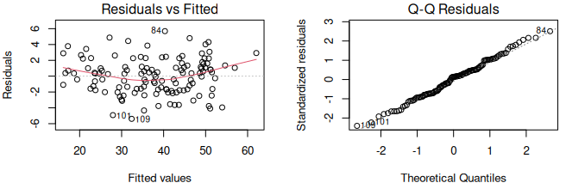

Figure 4 (Residual vs Fitted on left, Q-Q Residuals on right)
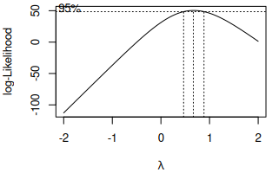

Figure 5 (boxcox curve with optimal )
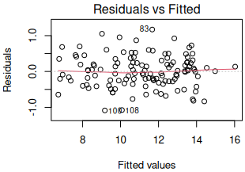
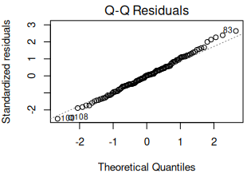

Figure 6 (Residual vs Fitted on left after transformation, Q-Q Residual on right after transformation)
Looking at Figure 6 we can see equal variance is no longer violated and normality still holds Our transformed/final model will look like this,

Note that this transformation changes the interpretation of our model, it is no longer a predictive win model, it is now a regular season score, and the higher the score the better season.
2. HYPOTHESIS TESTING
Looking at Figure 7 the p-values of all explanatory variables except for PP% are much less than 0.05, so we can say they are significant at the 0.05 level. PP% is close to 0.05 so let’s conduct a t-test to prove it’s significance.
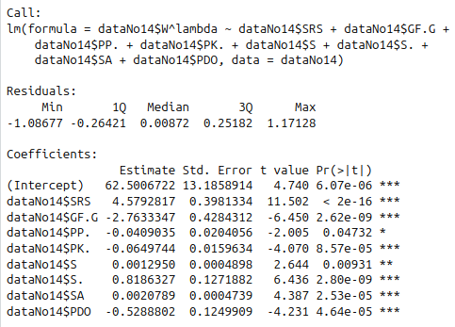

Figure 7 (Summary output of Regular Season Score)
2.1 T-TEST OF PP%
I am testing the null hypothesis that PP% is not a significant factor at in season score ( ), and the alternate hypothesis that it is (). Using the test statistic . We reject is , 2.0045 > 1.960, therefore we can reject the null hypothesis and say that PP% is a significant factor at the 0.05 level.
3. CONCLUSION
Through rigorous model selection and hypothesis testing we have come up with the regular season score statistic,

With , and the explanatory variables . Just for fun let’s show last years standings by regular season score.
3.1 LAST SEASON’S STANDING BY REGULAR SEASON SCORE
Ranking teams by their regular season score we get:
1. Dallas (14.067) 2. Florida (13.935) 3. Winnipeg (13.884) 4. New York Rangers (13.733)
5. Vancouver (13.523) 6. Carolina (13.444) 7. Colorado (13.401) 8. Edmonton (13.382)
9. Toronto (13.344) 10. Boston (13.004) 11. Los Angeles (13.001) 12. Tampa Bay (12.859)
13. Nashville (12.523) 14. Vegas (12.457) 15. Detroit (12.241) 16. Pittsburgh (11.869)
17. Buffalo (11.730) 18. St. Louis (11.695) 19. New York Islanders (11.565) 20. Minnesota (11.361) 21. Arizona (11.316) 22. Ottawa (11.310) 23. Calgary (11.127) 24. Philadelphia (10.934)
25. Washington (10.826) 26. New Jersey (10.776) 27. Seattle (10.702) 28. Montreal (9.908)
29. Columbus (9.588) 30. Anaheim (8.946) 31. Chicago (8.269) 32. San Jose (6.770)

